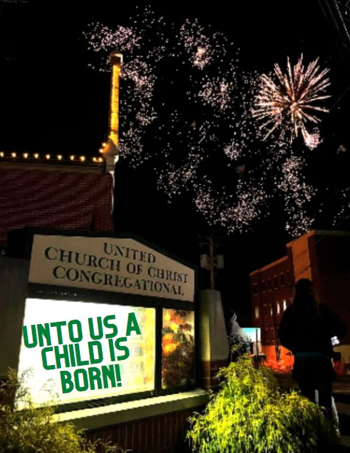
UNITED CHURCH OF CHRIST, CONGREGATIONAL
217 E. Liberty St. Medina, Ohio 44256 330-725-4559 www.uccmedina.org

***Assisted Listening Devices Available – Please Ask Your Usher***


LIVE STREAMING OF THE SANCTUARY SERVICE IS AVAILABLE AT UCCMEDINA.ORG
“Welcoming, Loving, Serving, Where God has No Limits”

Welcome and Merry Christmas! We are so glad that you have joined us for worship this morning.
Please take a moment to sign the attendance pads, (located at the end of each pew) so that you
know who is worshipping near you and you may greet them by name.

*Those who are able please stand

PRELUDE "He Is Born (Il le né)” - setting, Lynn Arthur Koch Cathy Fafrak, Organist

WELCOME

PASSING THE PEACE

*CALL TO WORSHIP
Leader: God is with us.
People: Emmanuel is here!
Leader: Joy to the world!
People: The Lord is Come.
Leader: Let us receive one another and lift up songs and prayers together.
People: In celebration. In solidarity. In joy. Come let us worship!

*CAROL “Angels From the Realms of Glory”

Angels from the realms of glory,
Wing your flight o'er all the earth;
As you sang creation's story,
Now proclaim Messiah's birth:
Come and worship, Come and worship,
Worship Christ, give thanks and sing!

Shepherds, in the fields abiding,
Watching o'er your flocks by night,
God with us is now residing,
Yonder shines the infant Light;
Come and worship, Come and worship,
Worship Christ, give thanks and sing!
Sages, leave your contemplations,
Brighter visions beam afar;
Seek the great desire of nations,
Guided by Christ’s natal star;
Come and worship, Come and worship,
Worship Christ, give thanks and sing!
Saints before the altar bending,
Watching long in hope and fear,
Suddenly your prayers attending,
Christ beside you shall appear:
Come and worship, Come and worship,
Worship Christ, give thanks and sing!

*COMMUNITY PRAYER
Gracious Mystery, you’ve come to us. Come for Good News. May we change our minds about you and about this news. May we not be afraid of this good news of great joy for all people. Glory to you, in the highest heaven and in our next breath. On earth, peace. On earth, Joy. On earth, hope. For your love is here within and among us. Thanks be to you our God, our Christ, our Spirit. One God forever and ever. Amen.

*CAROL “The First Noel”

The first Noel the angel did say
Was to certain poor shepards in fields as they lay:
In fields where they lay a keeping their sheep
On a cold winter's night that was so deep.
Noel Noel Noel Noel
Born is the King of Israel.

They looked above and saw a star
Shining in the east beyond them far:
And to the earth it gave great light
And so it continued both day and night.
Noel Noel Noel Noel
Born is the King of Israel.
And by the light of that same star
Three sages came from country far;
To seek for a King was their intent,
And to follow the star wherever it went.
Noel, Noel, Noel, Noel,
Born is the King of Israel.

This star shone bright in the north-west;
O'er Bethlehem it seemed to rest,
And there it did both stop and stay,
Right over the place where Jesus lay.
Noel, Noel, Noel, Noel,
Born is the King of Israel.

Then entered in those magi three,
And bending low upon their knee,
They offered there, in great reverence,
Their gold and myrrh and frankincense.
Noel, Noel, Noel, Noel,
Born is the king of Israel.

SHARING OF GOOD NEWS

The Lord’s Prayer
Our Father who art in heaven. Hallowed be thy name. Thy kingdom come. Thy will be done on earth as it is in heaven. Give us this day our daily bread
and forgive us our debts as we forgive our debtors. And lead us not into
temptation, but deliver us from evil. For thine is the kingdom and the power
and the glory forever. AMEN.

HYMN SING

COMMUNITY PRAYER (Inspired by David Whyte’s poem “What to remember when waking” in The House of
Belonging page 27)

Dear Neighbor, you are not a troubled guest on this earth. You are not an accident amidst other accidents. You were invited. You are being nurtured into being. Be not afraid. Do not give into despair. There is love to be had. There is hope to be found. Let us keep Christmas through our welcome, our love, and our service.

I thank God for you. Praise be to God. Amen.

*CAROL “Good Christian Friends, Rejoice”

Good Christian friends, rejoice
With heart and soul and voice;
Give ye heed to what we say:
Jesus Christ is born today;
Ox and ass before him bow,
And he is in the manger now.
Christ is born today! Christ is born today!
Good Christian friends, rejoice
With heart and soul and voice;
Now ye hear of endless bliss:
Jesus Christ was born for this!
He has opened heaven's door,
And we are blest forever more.
Christ was born for this! Christ was born for this!

Good Christian friends, rejoice
With heart and soul and voice;
Now ye need not fear the grave;
Jesus Christ was born to save!
Calls you one and calls you all
To gain his everlasting hall.
Christ was born to save! Christ was born to save!

*BENEDICTION
Leader: Go from here knowing that God is here and that you are the gift.
People: Life is a gift. Let us enjoy it. Amen.

*POSTLUDE “Good Christian Men, Rejoice” - setting, Wilbur Held Cathy Fafrak, Organist
++++++++++++++++++++++++++++++++++++++++++++++++++++++++++++++++++++++++++++++++
Music in this bulletin reprinted/podcast/streamed with permission under:
ONE LICENSE, License #A-605137. All rights reserved and CCLI, License #1637380 & #21333812

There is an offering plate if you feel led to deposit your envelope or an offering there.
You can also give through our Realm app or get the link to give by texting UCCMEDINA to 73256. Thank you for your prayerful consideration!

PASTORAL STAFF
Rev. Dr. Luke Lindon, Senior Minister - luke@uccmedina.org
Rev. Meghan Malone, Associate Pastor of Youth & Mission - meghan@uccmedina.org
Karen Brocco-Kish, Visitation Pastor – karen@uccmedina.org
Ryan Collins, Ministerial Intern - ryan@uccmedina.org

OFFICE STAFF
Cindy Korecky, Office Manager - office@uccmedina.org
Jeff Miller, Financial Director - jeff@uccmedina.org

PROGRAM STAFF
Stacie Yates, Director of Christian Education – stacie@uccmedina.org
Nicole Rubino, Co-Director of Youth – nicole@uccmedina.org
Jennifer Cochran, Director of Music - jenny@uccmedina.org
Cathy Fafrak, Organist – cathy@uccmedina.org
Jennifer Vilimonovic, Director of Hobby Horse Preschool – jen@uccmedina.org
Rebecca Rosen, Nursery Supervisor
Sharon Perry, Custodian


POINSETTIAS

DONOR IN MEMORY OF

Patrick & Jennifer Acurio Rafael H. Acurio
Syd & Pete Benson Our parents
Mary Bessick Mr. & Mrs. Arthur R. Dunger
Nancy Brintnall Howard & Helen Gross
The Burdick Family Edward Lichtenberg
Richard & Dorie Christy Our parents
Jan & Tad Coleman Jack & Jean Post
Sue & Ken Dean Geroge Elliott Dean
John & Joyce Drotos Our parents
Edward L. Farnham Helen W. Farnham
Beth & Craig Hari Our parents
Arnold & Cheri Ingraham Berneta Ingraham
Arnold & Cheri Ingraham Willard & Carol Brenneman
Faye Jessie Carl Jessie
The Johns Family Jerry Johns
Dick & Joyce Komjati Our parents
Karen Leidy Kitty & Bill Andrews
Karen Leidy Thelma & Glen Leidy
Karen Leidy Sherry Fodor
Pete & Alice Metzloff Jeannette Pettit, Sahara Pettit, & Pete & Alice's (Maxine & Hayden) parents
Claire & Philip Nicholson Ruth Rose Wilks Nicholson (Mother)
Earle & Medith Olson Loved ones
Alan Parkhurst Sandy & Howard Parkhurst
Dennis & Allayne Reese Our parents
Barb Rosen Keith Rosen
Jane & L.B. Schaefer Our parents
Greg & Barb Shaffer Our parents
Bonnie Shuman Loved ones
Ken & Judy Smith Perry Arenz
The Spence Family Victor Sopko, Jr.
The Spence Family Ron Spence
The Spence Family Mr. Henry
The Spence Family Mr. Maury
The Vilimonovic Family Dragisa "Danny" Vilimonovic
The Wolff Family Linda Hegyi-Schrambeck
Mark & Karen Woodling Loved ones

POINSETTIAS

DONOR IN HONOR OF

Patrick & Jennifer Acurio Charlie & Beth Weil
Ashley Bonsell Mother & Father
Sue & Ken Dean Herbert Royal Dean, IV
Bill & Millie Holdford Olivia, Addisyn & Kaelyn Miller
The Johns Family Family & Friends
Claire & Philip Nicholson Our 53rd Wedding Anniversary (12/21/22)
Dean & Beth Winquist Our parents

THE PILGRIM MESSENGER
DECEMBER 25, 2022

May 10, 2015

, 2007

NOVEMBER 26, 2006

“Welcoming, Loving, Serving, Where God Has No Limits.

More Than Church On Sunday!”

Live streaming of the Sanctuary service is available at www.uccmedina.org/live

December 25, 2022 thru January 1, 2023
WEEK AT A GLANCE
Sun CHRISTMAS DAY
10:00 am One Service Only
Cozy Christmas

Mon CHURCH OFFICE CLOSED

Tues 7:00 pm Bible Study

Wed 10:30 am Quilters

Thurs

Fri CHURCH OFFICE CLOSED AT NOON

Sat

Sun NEW YEARS DAY
10:00 am One Service Only

OFFICE CHRISTMAS HOURS
The church office will be closed on Monday, December 26th and will reopen at 9 a.m. on Tuesday, December 27th due to the Christmas holiday.
The church office will also be closed on Monday, January 2nd in observance of the New Year.

PILGRIM MESSENGER MAILING
We will not be mailing the Pilgrim Messenger
Between Christmas and New Year’s
on December 29th.
We will resume mailing again on Thursday, January 5, 2023

Worship Highlights: 10:00 am

Communion Table: The flowers are given by
Dick & Dorie Christy

NEW YEARS SERVICE
We will have one service of worship on Sunday, January 1st at 10 a.m. Communion will be offered.

THE VETERANS OF THE CROSS OFFERING
The Christmas Fund for the Veterans of the Cross and the Emergency Fund has been caring for active and retired clergy and lay employees of the United Church of Christ for over 100 years! These funds provide emergency grants, supplementation of small annuities and health premiums, and Christmas “Thank You” gift checks each December to our lower-income retirees. The generous financial offerings given at Christmas time by United Church of Christ congregations enable the Pension Boards’ Ministerial Assistance Team to provide financial support to those who serve and have served the Church. Please consider offering a monetary amount, on Christmas Eve, to help support the Veterans of the Cross.

POINSETTIAS
If you have ordered a poinsettia and wanted to claim it, you may take it home after the 10 a.m. service today, December 25th.

END OF YEAR GIVING STATEMENTS
In an effort to be more efficient and try to save money, your End of Year Giving Statements will be emailed to you this year so you can print them out if you need them. If we do not have an email on file for you and you would like your statement mailed, please contact the church office. You can pick it up in the church office or we can mail it to you. If you have not yet turned in your pledge, please consider doing it soon. Your pledge is extremely important in helping forecast our 2023 budgets. Blank cards are available in the pew racks and on the website. You may also signup in REALM. If you need assistance, please give Jeff Miller a call at 330.725.4559 EXT: #13
* Please note that for your 2022 or 2023 contribution to be eligible for a 2022 tax deduction, we must receive your contribution by 12/31/22.

WELCOME BAGS
The Evangelism Team would like to welcome first time visitors to our church! We’re so glad you are here. Please be sure to grab a welcome bag before you leave which is our gift to you. The white handled welcome bags are located near the tower doors in the sanctuary, located near Fellowship Hall and in the East Room. Thank you for visiting Medina UCC today where we are welcoming, loving, and serving.

SAVE THE DATE
IT’S BACK, so please mark your calendars as the Ladies and Girls Tea will be held on Saturday, May 13th. “All The Tea In China” will be the program presented by our own Vicki Miller. More information will be coming, and ticket sales will begin in April. Please direct questions to Beth Hari, Becky Weber, or Darlene Fazekas.

COMMUNION TABLE FLOWERS
The 2023 Flower Chart is now hanging in the East Room hallway. This is a wonderful way to honor or remember someone, or to celebrate a special occasion. Please fill in your name and write “Church” or “Self” to let us know if you would like the church to order the flowers for you or if you will be ordering them yourself. The cost of the flowers ordered through the church office is $22.50. Also, please write what you would like printed in the Messenger and if you want to claim your flowers after the 10:30 service.

ANNUAL REPORTS DUE SOON
Annual Report time is near! As we are working on our 2023 budget, we will also need a few other reports to put this together. I will need an annual report from our Church Clerk, Church Treasurer, the Stewardship Team, and the Endowment Team. Please have your report to me no later than Friday, January 6th. Thank you.

A SPECIAL THANK YOU
Thank you to everyone who attended "A Jazzy Christmas". A great time was had by all! Our handbell and Chancel choirs were brilliant, and the Gateway Band was welcomed with open arms and hearts. Thank you to all who contributed to the baked goods and craft sale in any way! We raised well over a thousand dollars that will go to the music department! Merry Christmas to all!

COMMUNION TABLE FLOWERS
We have several openings to sponsor the communion table flowers. Please consider signing up today! This is a wonderful way to honor or remember someone, or to celebrate a special occasion. Please fill in your name and write “Church” or “Self” to let us know if you would like the church to order the flowers for you or if you will be ordering them yourself. The cost of the flowers ordered through the church office is $22.50. Also, please write what you would like printed in the Messenger and if you want to claim your flowers after the 10:30 service.


PRAYER CONCERNS
SUPPORT
Beth | Strength and healing
Donene Bradshaw | Strength and healing-health & breathing issues
Brian | Strength and healing from lung cancer
Tad Coleman | Strength and healing
Kathy Duncan | Strength and healing
Lindsay English | Strength and healing
Jim Gilder | Strength and healing from cancer
Linda Hjort | Strength and healing from stroke
Ellie Jack | Strength and healing from Covid
David Kunkleman | Strength and healing from a hip replacement
Elizabeth Mason | Strength and healing
Tammie McGivern | Strength and healing from a broken hip
Barbara Michal | Prayers for anxiety
Carrie Park | Strength and healing
Alexis Raines | Strength and healing
Jaclyn Raub | Strength and healing for foot pain
Randy Rice | Strength and healing from cancer
John Root | Strength and healing
Holly Schwamel | Strength and healing
Greg Shaffer | Strength and healing
Jim Shaffer | Strength and healing from cancer
Dave Sinclair | Strength and healing from shoulder surgery
Terry Yancer | Strength and healing

Sympathies

Our deepest Christian sympathies go to the family and friends of Michelle (Tony) Colon on the death of her father, Rev. Robert Lahr, on December 18, 2022.

CPT Dakota Thomasini | Air Force, San Antonio, TX (Carolee Rafn’s granddaughter)
CPT Kyle Thomasini | Air Force, San Antonio, TX (Carolee Rafn’s grandson-in-law)
CPL Andrew Root | Marines, Camp Pendleton, CA (Brad & Kathy Root’s son)
PFC Joe DeSario | Army/National Guard, OH (Paul & Kelly DeSario’s son)
LT Patrick Donnelly | Navy, Virginia (Joe & Lori Donnelly)
ST SGT Michael Fikter | Air Force, Poland (Greg & Barb Shaffer’s nephew)
CPL Greg Swayer | Army, Fort Bliss, TX (Stacie Yates’ cousin)
SGT Tyler Walschon | Army/National Guard, OH (John & Joan Walschon’s son)
Kyle Weekley | Army (Daubner Family)
MILITARY SUPPORT

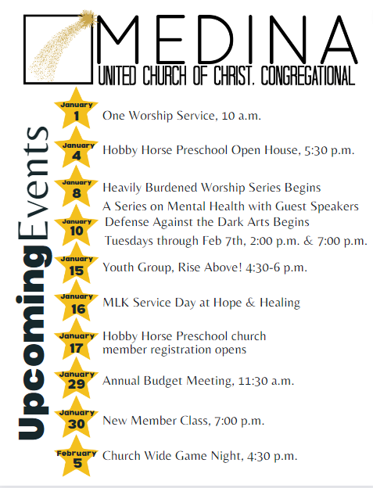

The deadline for submission of articles for NEXT Sunday’s Messenger is this Sunday at 11:30 am
Please submit articles to the church office at office@uccmedina.org
CHURCH OFFICE HOURS: 9:00 am – 3:00 pm MONDAY THRU FRIDAY

December 25, 2022
Christmas Day
Isaiah 52:7-10

Voice One: Radiant Child, On this Christmas day, we pray for peace to fill us,
as the waters renew a dry and desolate landscape

Voice Two: How beautiful upon the mountains
are the feet of the messenger who announces peace!

Voice One: Radiant Child, on this Christmas day, we pray for hope to guide us forward,
making a way where the path is rocky.

Voice Two: All the ends of the earth shall see the salvation of our God!

Voice One: Radiant Child, on this Christmas Day, we pray for joy to uplift us,
carrying us on the swift currents of laughter and community.

Voice Two: Listen! Your sentinels lift up their voices; together they shout for joy!

Voice One: Radiant Child, on this Christmas Day, we pray for love to surround us,
as the comforting and loving embrace of a trusted friend.

Voice Two: For the Lord has comforted his people; he has redeemed Jerusalem.

Voice One: Peace, Hope, Joy and Love!
May they fill, guide, uplift, and surround us now and always. Amen!

